 Assignment 1

Name : Aditya Latke
PRN : 1262252462
DIV : 1

1. PROBLEM STATEMENT:
Write a program in C to check whether a given year is a Leap Year
OBJECTIVE:

1. To understand the use of conditional statements in C programming.
2. To implement logical conditions for solving real-world problems.
3. To develop problem-solving skills using decision control structures.

THEORY:
1. Theory for conditional statements with syntax (if , if-else, if-else ladder) are
used in C programming :
Conditional statements are used in C programming to make decisions.
They allow the program to execute different blocks of code based on a condition (true or false).
A] If statement: The if statement is a decision-making statement in C.
It is used to execute a block of code only when a given condition is true.
If the condition is false, the statements inside the if block are skipped

Syntax:
if (condition)
{
statement(s);
}

Program:
#include <stdio.h>

int main()
{
int number = 10;

if (number > 0)
{
printf("The number is positive");
}

return 0;
}

Output:
The number is positive
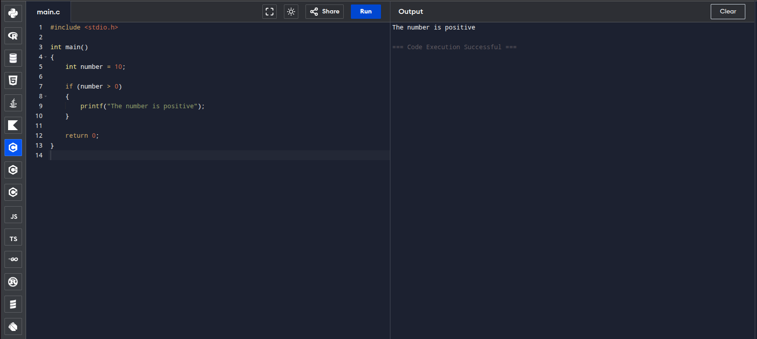

B] If-else statement: The if–else statement is used when there are two possible outcomes.
- If the condition is true, the if block is executed.
- If the condition is false, the else block is executed.
This ensures that one block of code always executes.

Syntax:
if (condition)
{
statement(s);
}
else
{
statement(s);
}

Program:
#include <stdio.h>

int main()
{
int number = -5;

if (number >= 0)
{
printf("The number is positive");
}
else
{
printf("The number is negative");
}

return 0;
}

Output:
The number is negative
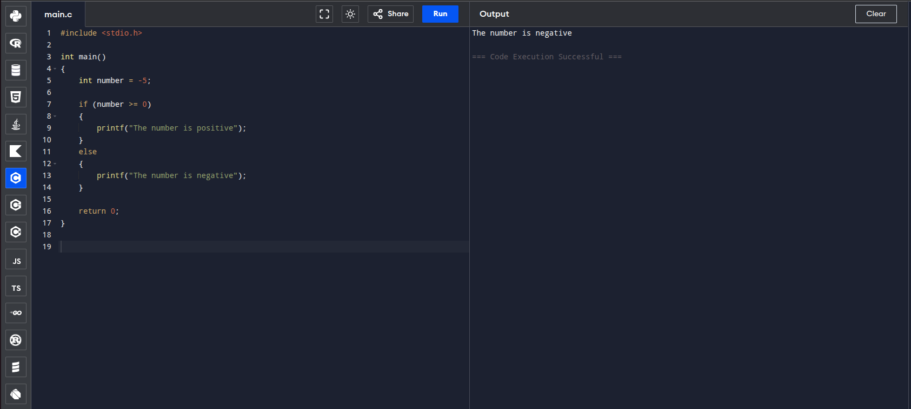

C] If-else ladder: The if–else ladder is used when multiple conditions need to be checked.
Conditions are evaluated from top to bottom.
- When a true condition is found, its block is executed.
- Remaining conditions are skipped.
- If none of the conditions are true, the else block executes.
Syntax:
if (condition1)
{
statement(s);
}
else if (condition2)
{
statement(s);
}
else if (condition3)
{
statement(s);
}
else
{
statement(s);
}

Program:
#include <stdio.h>

int main()
{
int marks = 75;

if (marks >= 90)
{
printf("Grade A");
}
else if (marks >= 75)
{
printf("Grade B");
}
else if (marks >= 50)
{
printf("Grade C");
}
else
{
printf("Fail");
}

return 0;
}

Output : Grade B
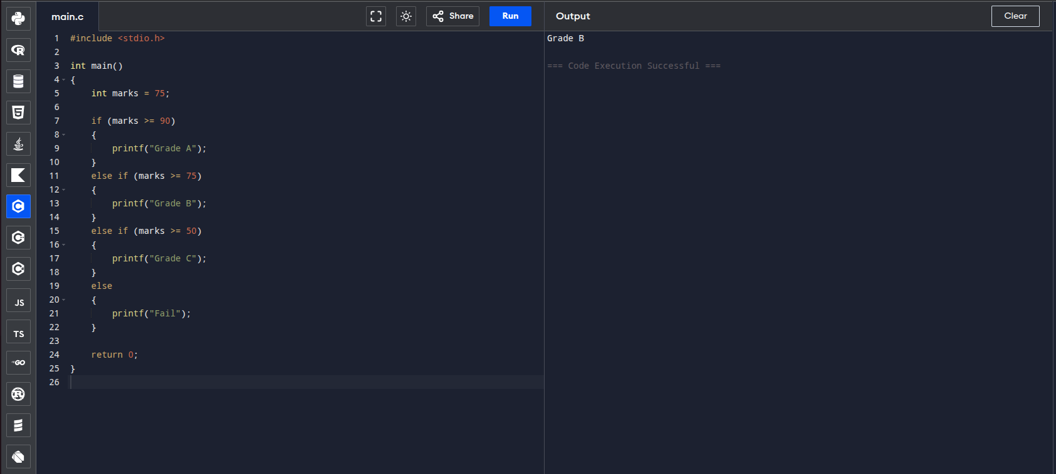

2. Theory for a Leap Year - year that contains 366 days instead of the usual 365
days.
Rules:
• A year is a leap year if it is divisible by 400, OR
• A year is a leap year if it is divisible by 4 but not divisible by 100.
A leap year is a year that contains 366 days instead of the usual 365 days.
The extra day is added to the month of February, making it 29 days.
Years like 2000 are leap years (divisible by 400)
Years like 2024 are leap years (divisible by 4 but not by 100)
Years like 1900 are not leap years (divisible by 100 but not by 400)

3. Algorithm:
STEP 1: Start
STEP 2: Enter the year y
STEP 3: Check if y%4==0 && y%100 !=0 || y%400==0
STEP 4: If the condition is true it is a leap year else it is not a leap year
STEP 5: Stop

PLATFORM: Linux
INPUT: Enter a year (integer value).

Year : 2026

Program:
#include <stdio.h>
int main() {
int year;
printf("Enter the year: ");
scanf("%d",&year);

if (year%400==0){
// printf("It is a leap year");
printf("It is a leap year");
}
else if(year%4==0){
if (year%100!=0){
printf("It is a leap year");
}
else{
printf("It is not a leap year");
}
}
return 0;
}

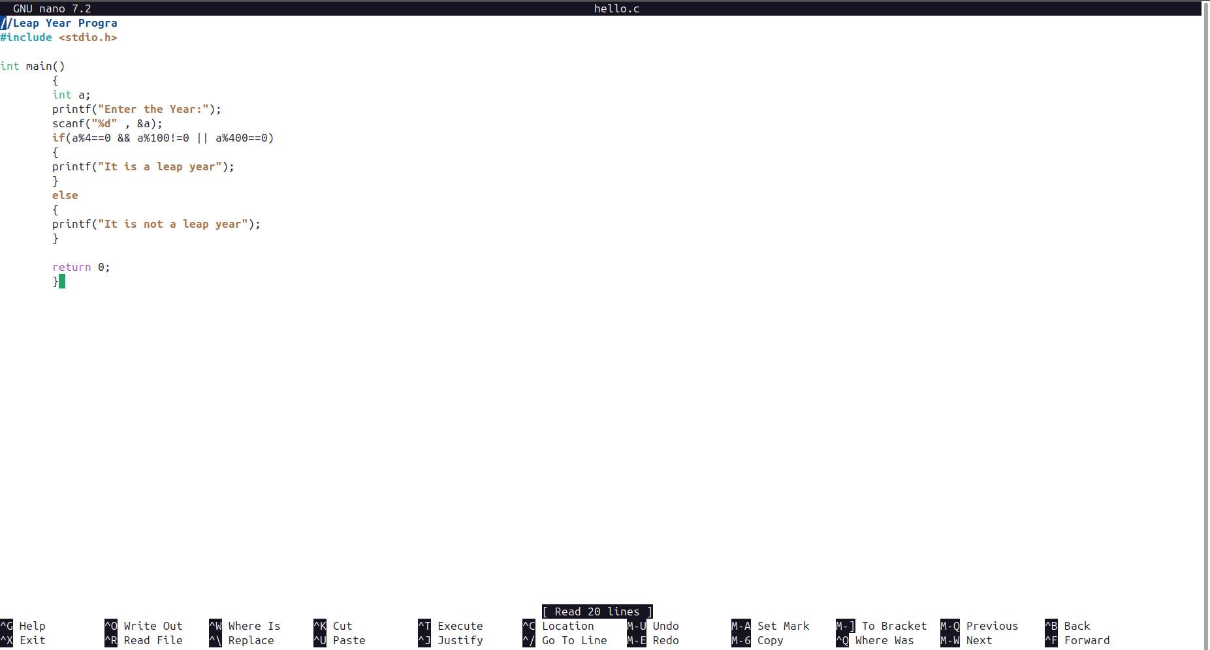

OUTPUT: Displays whether the entered year is a Leap Year or Not a Leap Year.

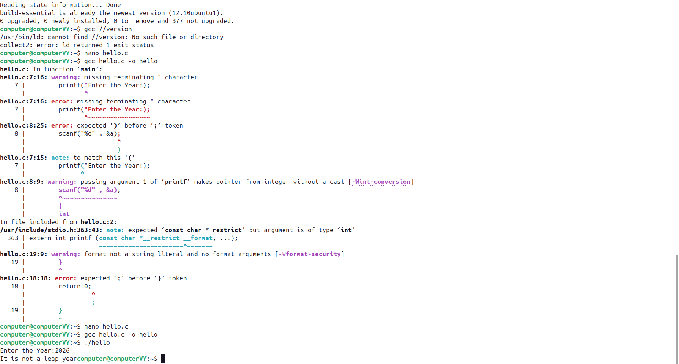

Thus we get the output that 2026 is not a leap year.

Sample Input
2024
Sample Output
2024 is a Leap Year
CONCLUSION: Thus, the program successfully checks whether a given year is a
Leap Year using conditional statements in C.

